**CTF Challenge: Cloud Computing**



**Cloud Computing?**

Cloud computing is a technology that enables the delivery of computing services—such as servers, storage, databases, networking, software, analytics, and intelligence—over the internet (“the cloud”) to offer faster innovation, flexible resources, and economies of scale. Here’s a detailed overview of cloud computing:

### **Key Concepts of Cloud Computing**

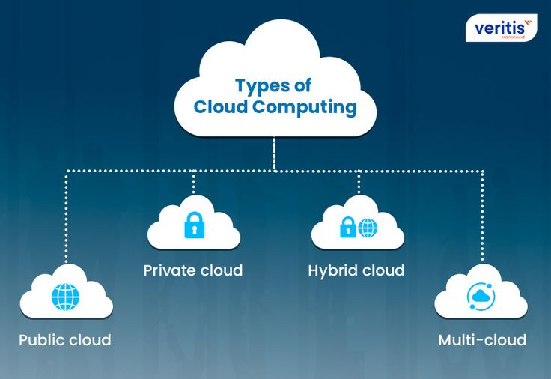

1. **Deployment Models**:
   * **Public Cloud**: Services are delivered over the public internet and shared across multiple organizations. Examples: Amazon Web Services (AWS), Microsoft Azure, Google Cloud Platform (GCP).
   * **Private Cloud**: Services are maintained on a private network for a single organization, offering enhanced security and control.
   * **Hybrid Cloud**: A mix of public and private cloud services with orchestration between them, allowing data and applications to be shared.
   * **Multi-Cloud**: Utilization of two or more cloud computing services from different providers.

2. **Service Models**:

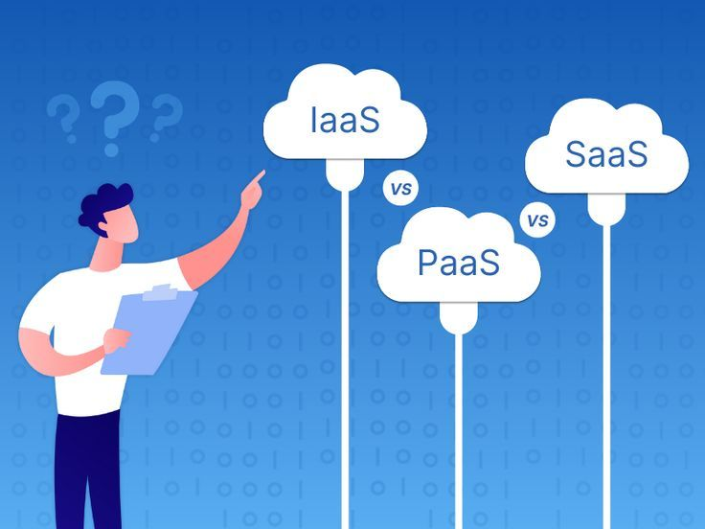

* **Infrastructure as a Service (IaaS)**: Provides virtualized computing resources over the internet. Users can rent virtual machines, storage, and networks. Examples: AWS EC2, Microsoft Azure Virtual Machines.
* **Platform as a Service (PaaS)**: Provides a platform allowing customers to develop, run, and manage applications without dealing with the infrastructure. Examples: Google App Engine, AWS Elastic Beanstalk.
* **Software as a Service (SaaS)**: Delivers software applications over the internet, on a subscription basis. Examples: Microsoft Office 365, Salesforce.

# **Capture the Flag (CTF) Challenges**

**Flag 1. What is the term for a cloud deployment model that combines public and private clouds?**

Answer: Hybrid

**Flag 2. Which cloud service model provides virtual machines and storage over the internet?**

Answer: IaaS

**Flag 3. What is the name of the malware that specifically targeted SCADA systems in Iranian nuclear facilities?**

Answer: Stuxnet

**Flag 4. Which cloud provider's service is abbreviated as GCP?**

Answer: Google

**Flag 5. What kind of attack is exemplified by the Mirai botnet?**

Answer: DDoS